CSE 145: Brilliant Pad Poo Vision

Milestone Report

## Completed Milestones

**Milestone 1a - Defining system specifications**

**Assigned to:** Derek, Kevin, Richard

**Deliverable:**

**High-Level System Specifications**

A. Overall Requirements:

1. Ability to detect dog - is dog anywhere on the pad, yes or no?
2. Ability to determine how dirty pad is - if pad is dirty, is it 10%, 20% 30%, etc. covered by waste?

B. Extra Requirements:

1. Ability to communicate with Brilliant Pad control module - can we talk to the module and simulate control variables such as amount of waste?
2. Integrate Kelton’s control system and our vision system on one Raspberry Pi

C. Hardware and Software Software Requirements

1. Raspberry Pi should be able to scan and process images through video stream
2. Image quality obtained from camera should be sufficient enough to be distinguish between clean pad and dirty pad

D. Mechanical Requirements

1. Camera should be mounted in a way such that it can view the entire Brilliant Pad
2. Prototype mounts should have adjustable height and angle for easy testing

**Milestone 1b - Assembling list of parts**

**Assigned to:** Kevin

**Deliverable:**

**List of Parts (main hardware components):**

Brilliant Pad + Pads

SHCHV Raspberry Pi Zero W Camera Night Vision Webcam + 2 Infrared IR LED Light

Raspberry Pi NoIR Camera Module V2

Raspberry Pi Zero

Raspberry Pi 3

3D Prints

**Milestone 1c - Create block diagram/system architecture**

**Assigned to:** Kevin

**Deliverable:**

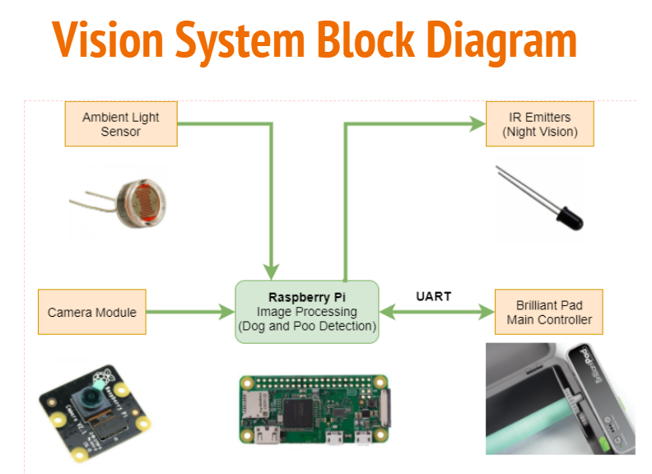

**Milestone 2a - Determine required dimensions**

**Assigned To:** Derek

**Deliverable:**

For this deliverable, dimensions were taken of two different Pi Cameras, as well as dimensions for a Raspberry Pi 3 and a Raspberry Pi Zero. Mounts will be designed for both combinations of devices.

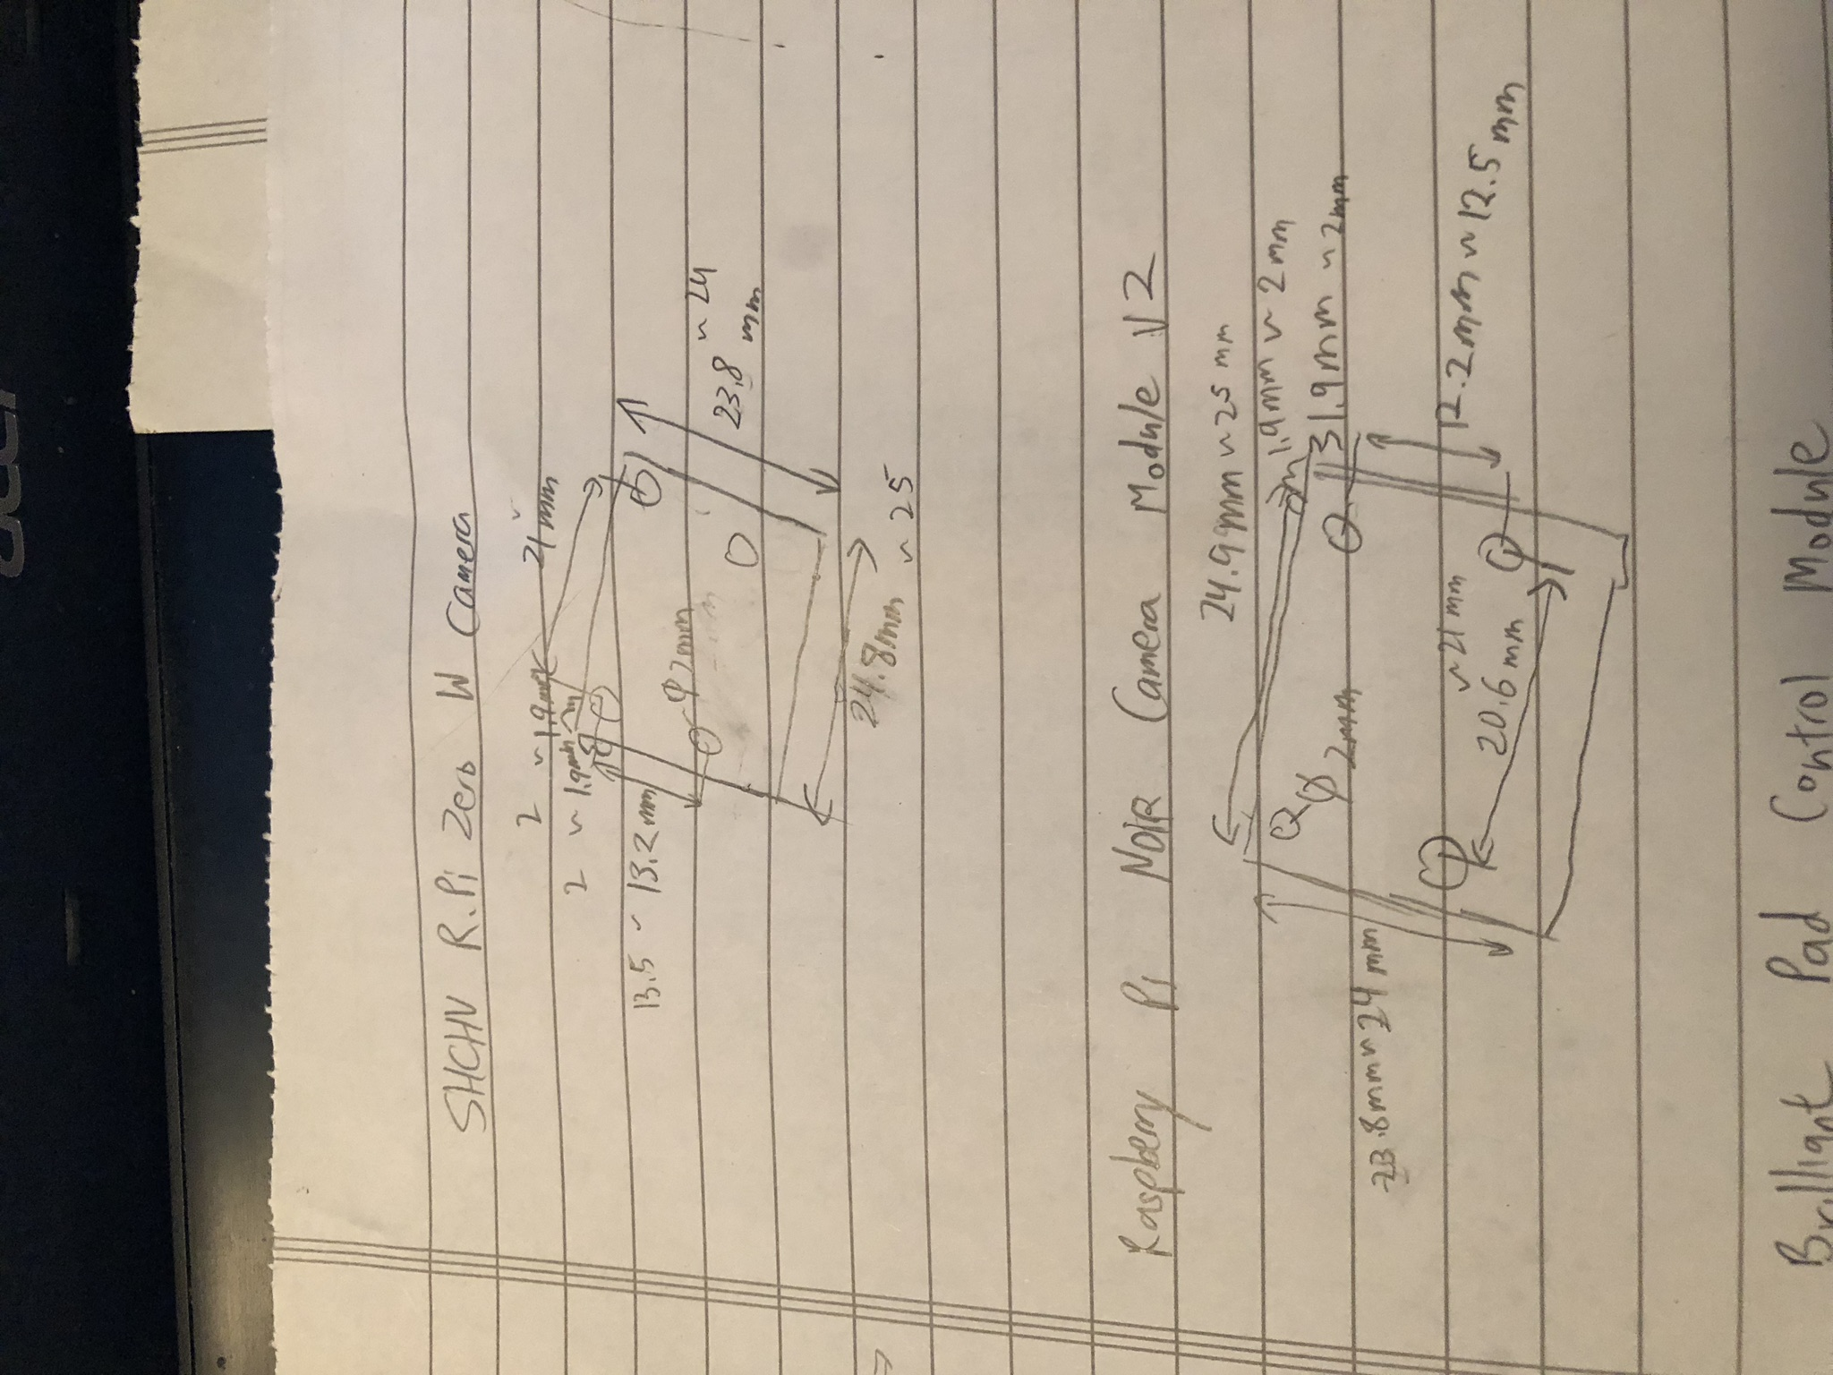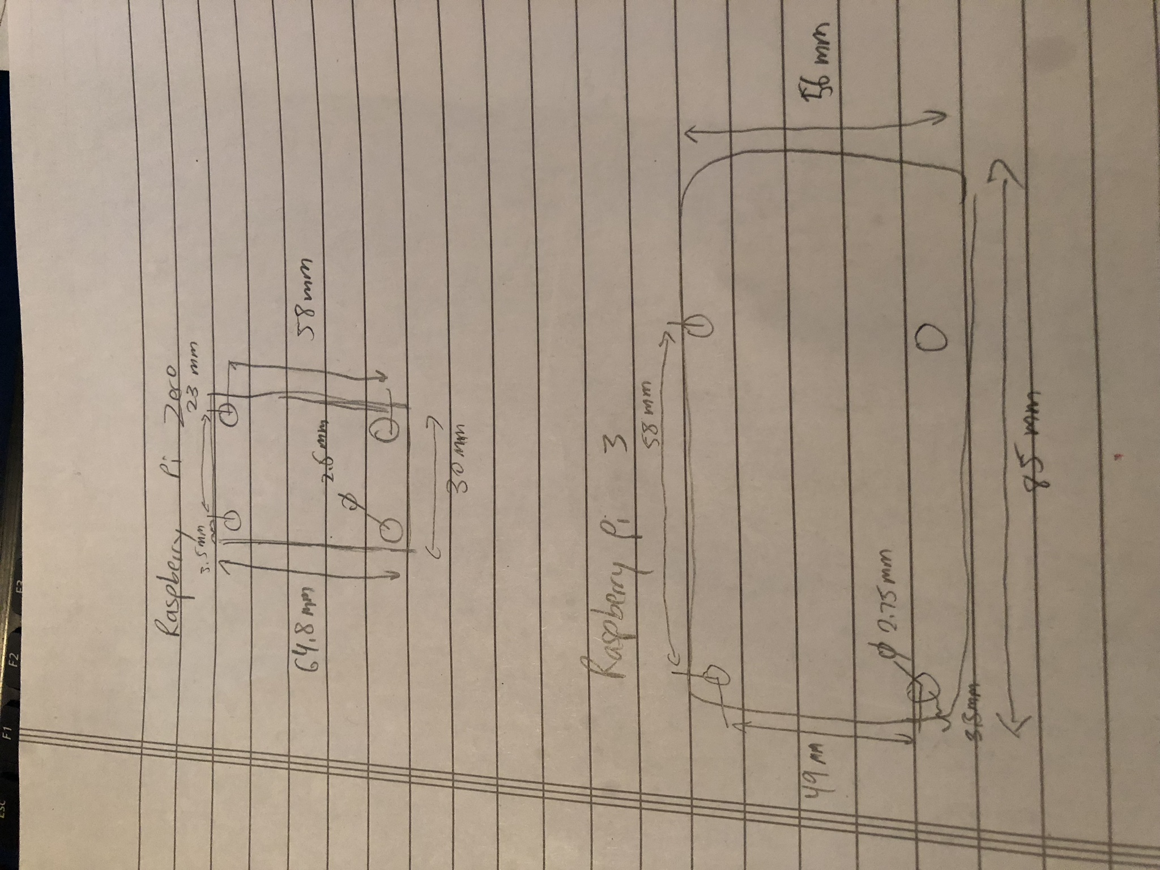

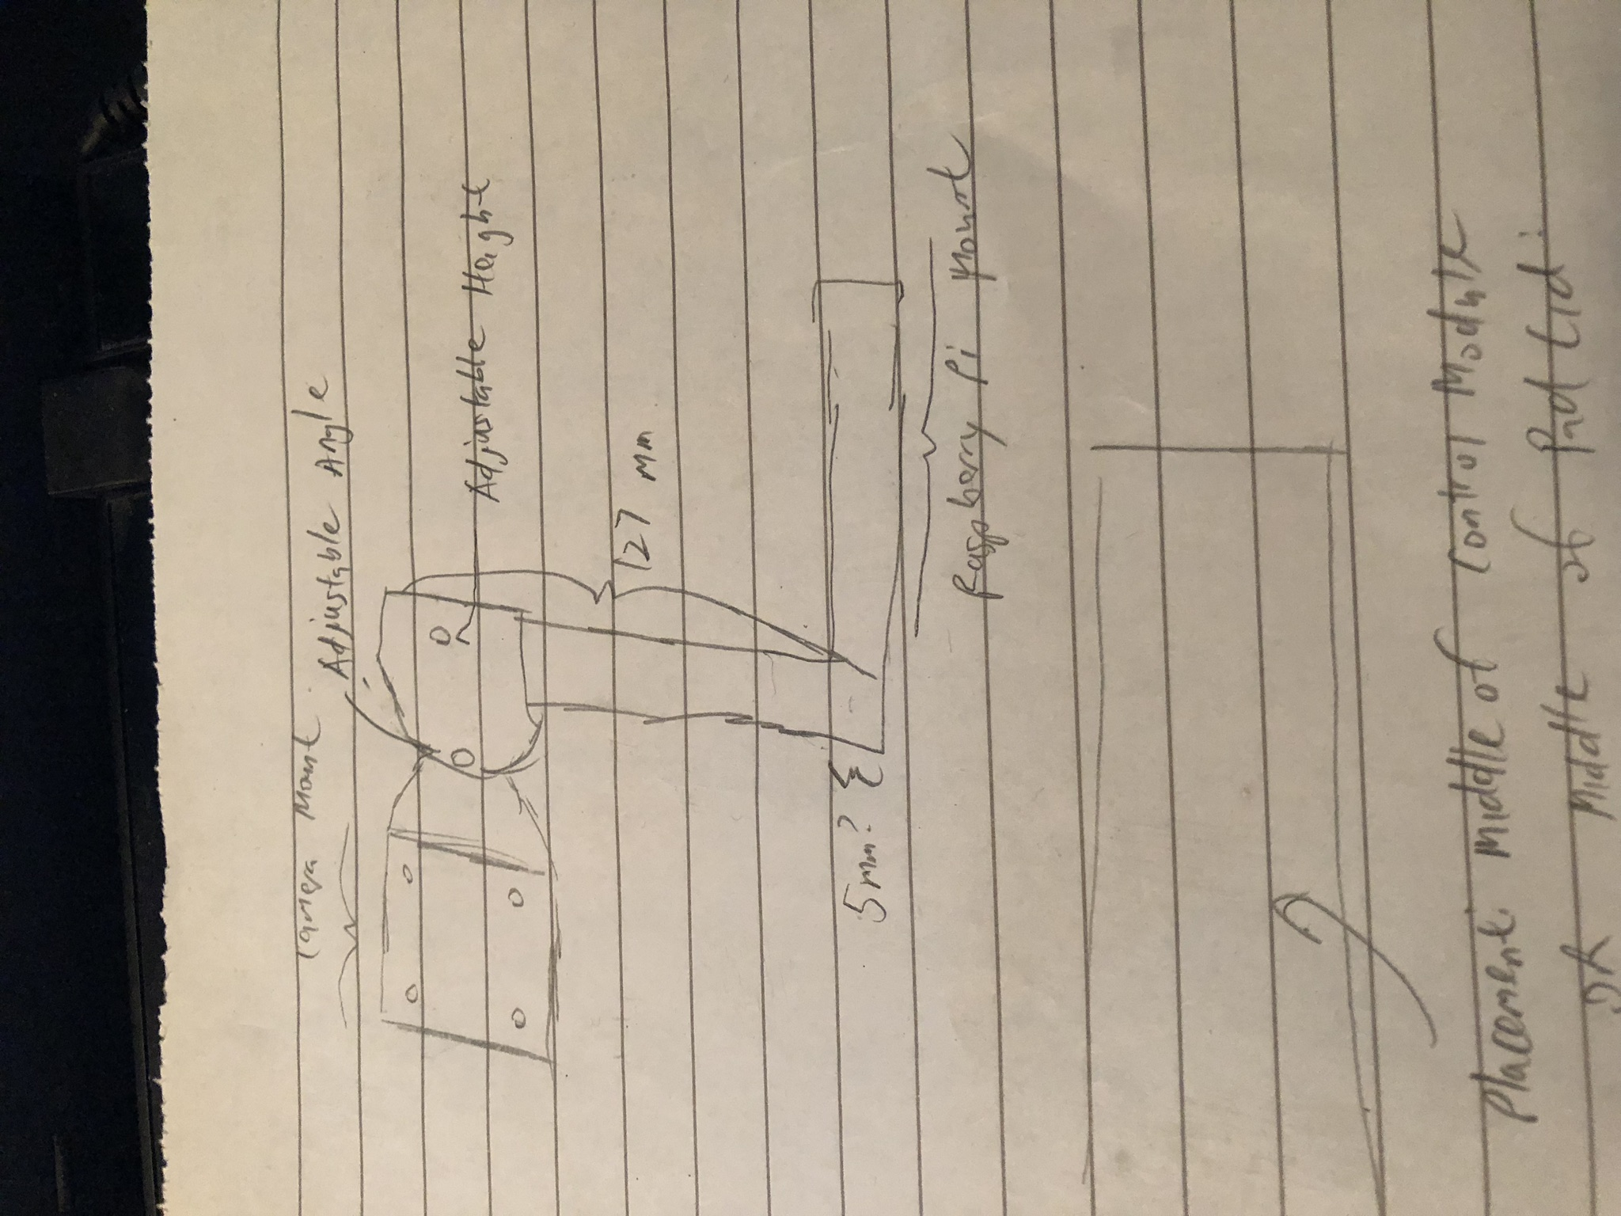

**Milestone 2b - Determine how and where the camera/sensor should be mounted on the Brilliant Pad**

**Assigned To:** Derek, Kevin, Richard

**Deliverable:**

There are two places where the camera can be placed for prototyping: on top of the control module, or on top of the lid next to the control panel.

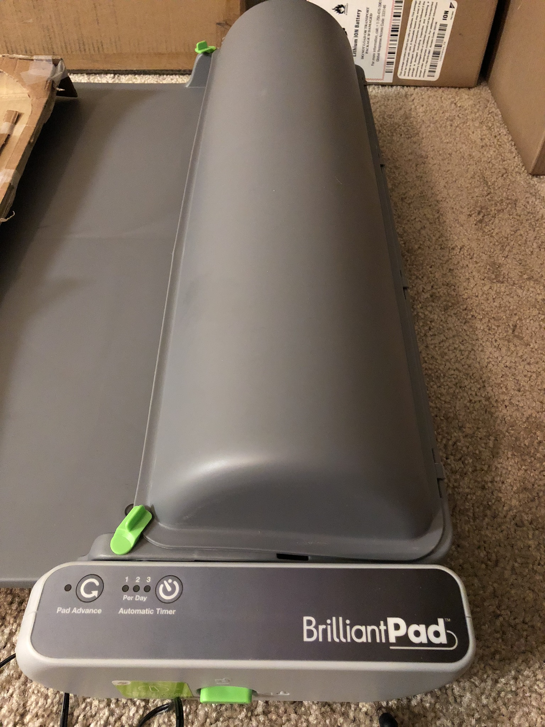

We will need to prototype several mechanical designs to see what camera positions will allow us to accurately classify how much waste there is. As there are also two cameras and two Raspberry Pi’s (Pi Zero and Pi 3), separate designs for each camera will have to be made.

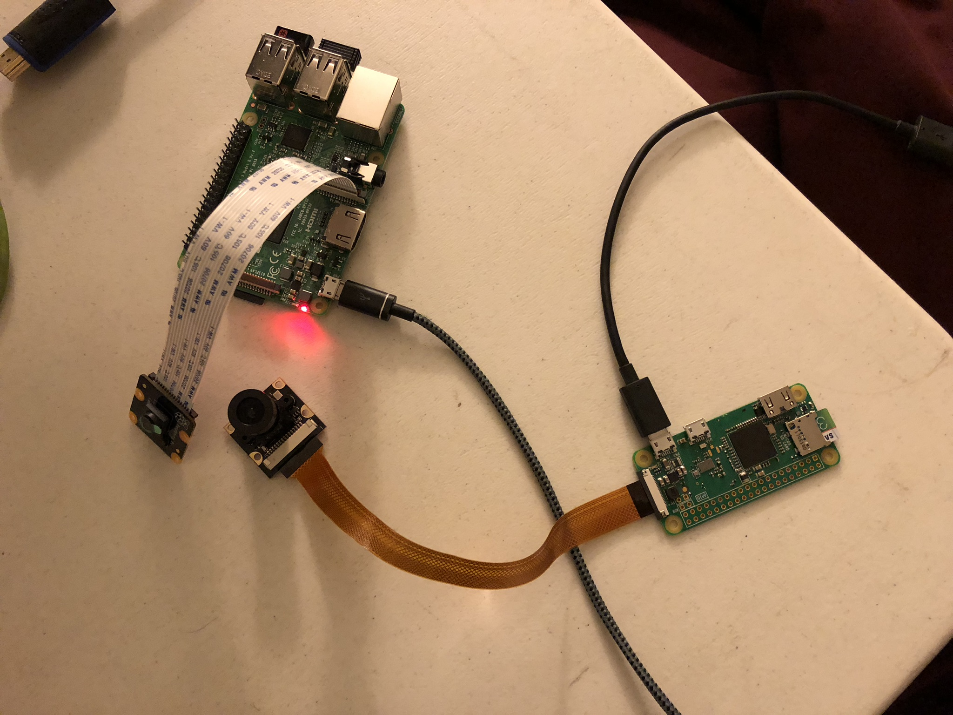

**Milestone 3 - CAD  
Definition:** Create 3D CAD for Camera + Raspberry Pi mounts

**Assigned To:** Derek  
**Deliverable:** Screenshot of 3D Models  
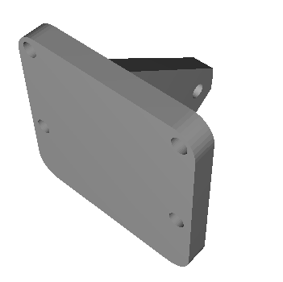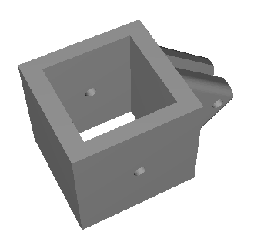

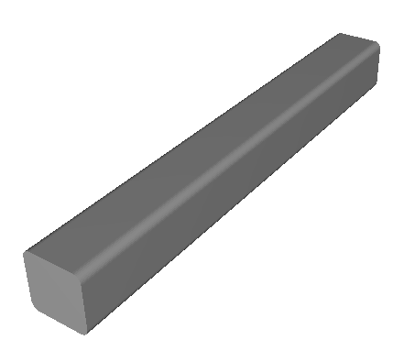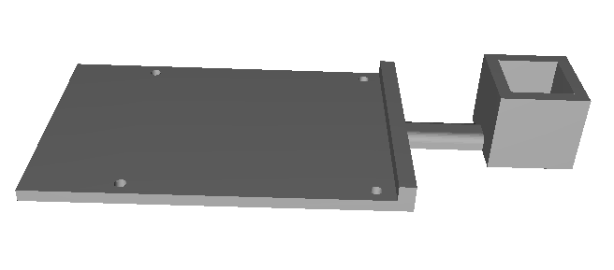

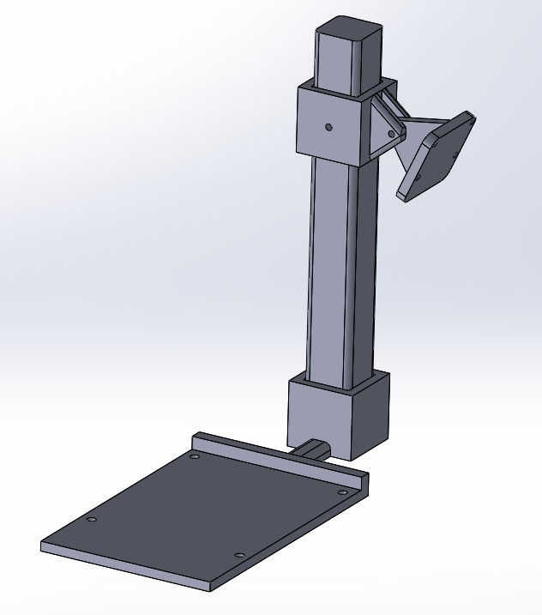

**Milestone 4 - Building  
Definition:** 3D Print the model that was created, and mount the required devices onto the Brilliant Pad

**Assigned To:** Derek, Kevin, Richard  
**Deliverable:**

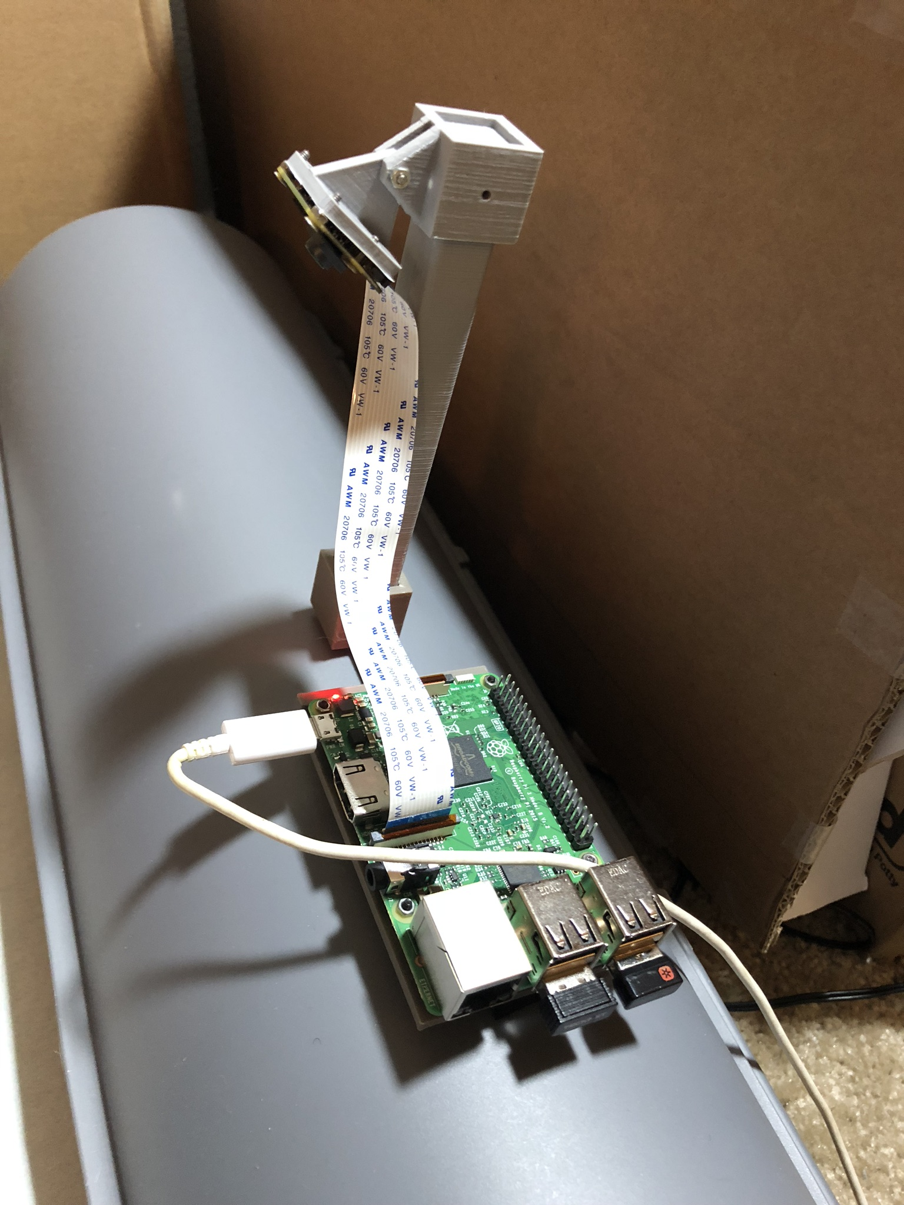

**Milestone 5 - Website Created  
Definition:** Create a “web presence” and document all required information about our project.

Assigned To: Kevin, Richard, Derek  
**Deliverable:**

<https://github.com/ktain/poovision>

**Milestone 6a - Image Capture**  
**Definition:** Capturing an image on the Raspberry Pi.

**Assigned To**: Kevin, Richard  
**Deliverable:**

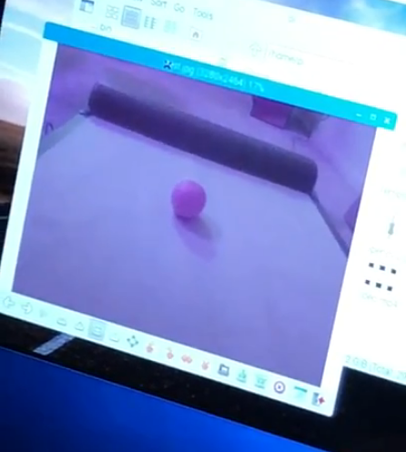

Video: <https://drive.google.com/open?id=1omwxRxggu47kKQtax5zoRCU-ac4_3Kdq>

**Milestone 6b - Isolate Pad Area from Non-Pad Area  
Definition:** Identify and extract the relevant parts of the image.

**Assigned To:** Kevin, Richard  
**Deliverable:** Show a black and white image separating pad from no pad area.

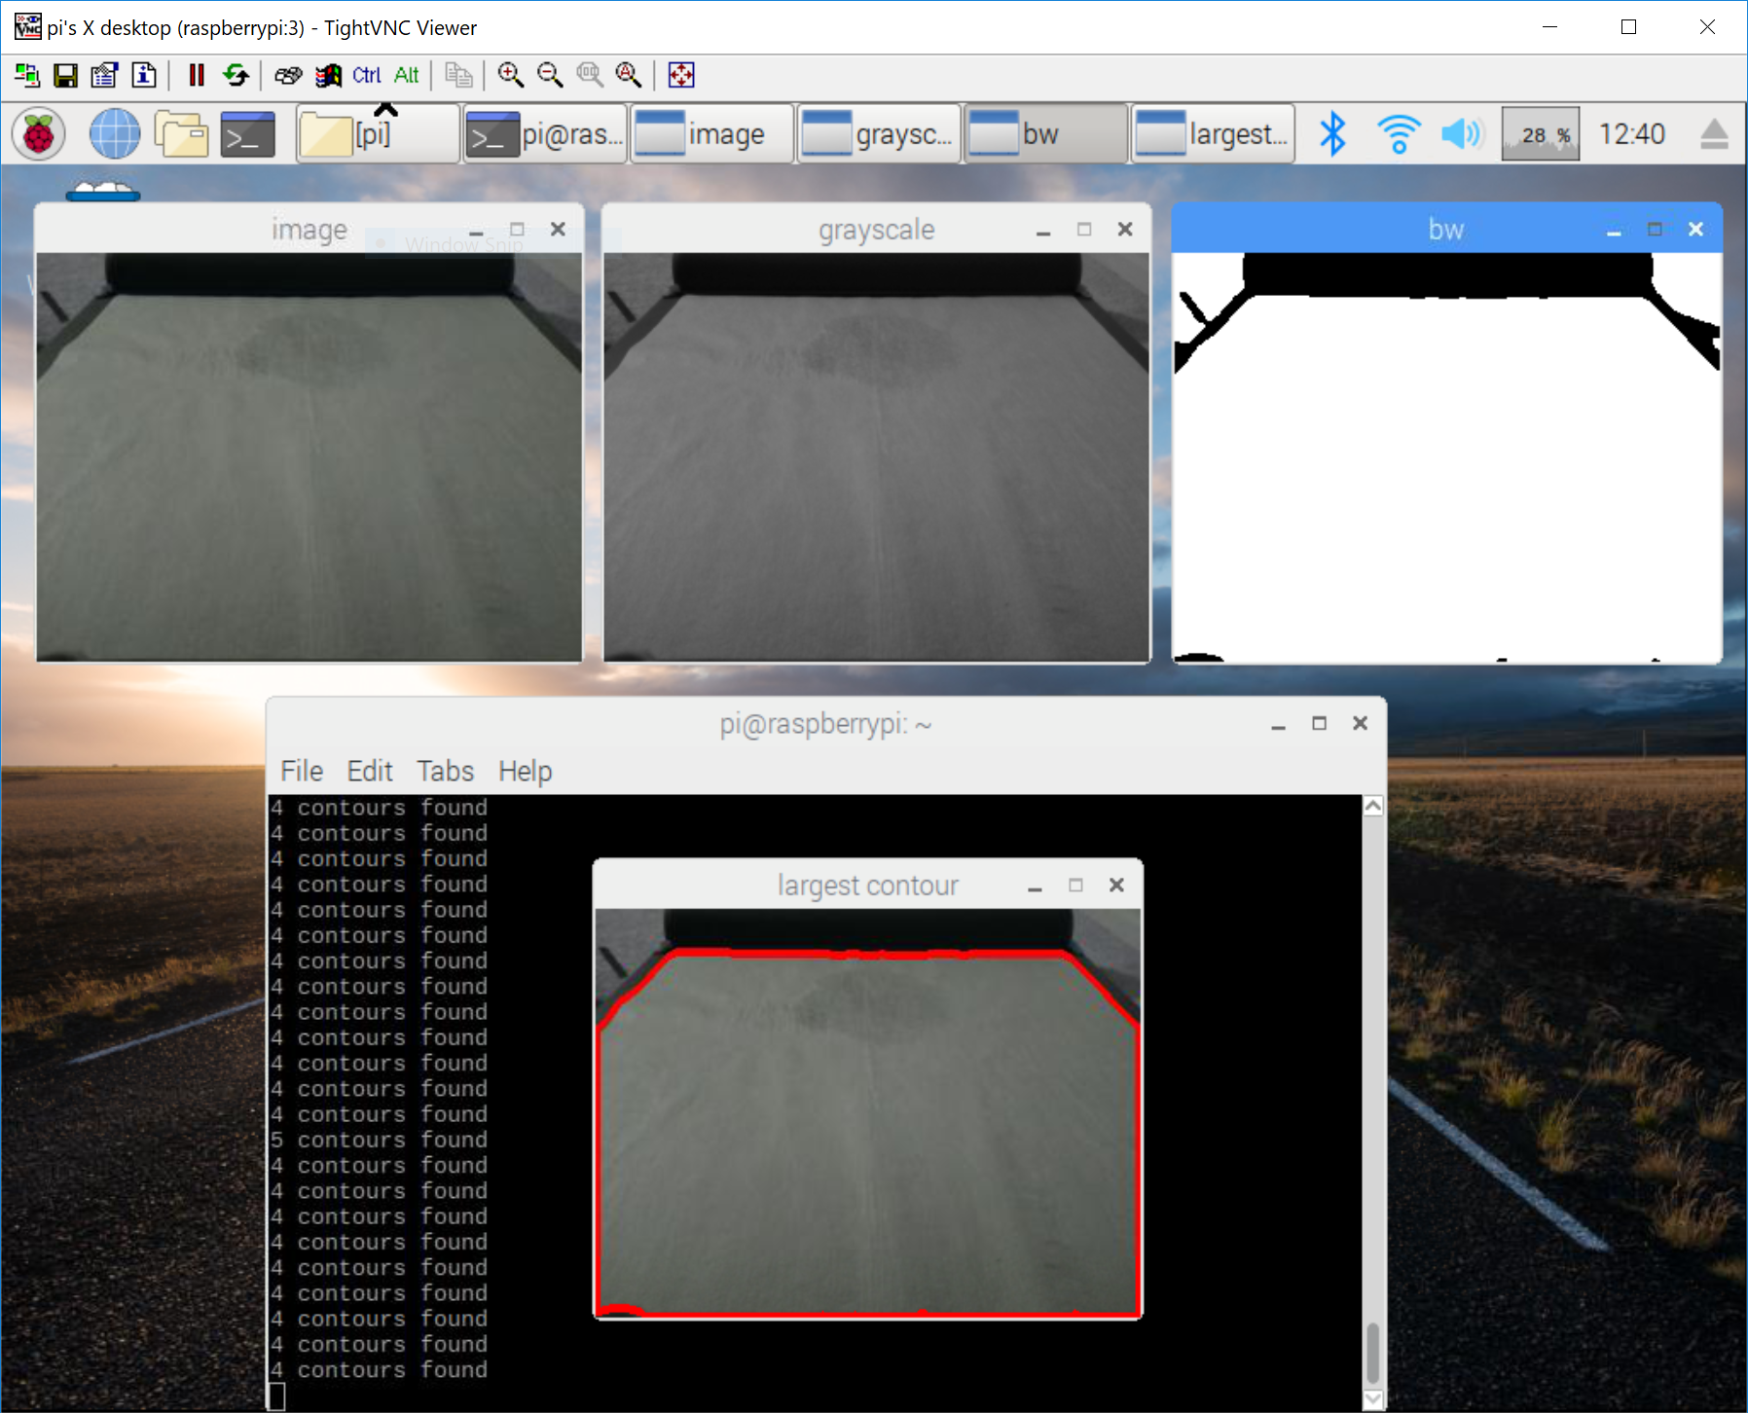

**Milestone 6c - Soil Level  
Definition:** Estimate how much of the pad is covered by waste

**Assigned To:** Kevin, Richard  
**Deliverable:** A video demonstration showing the module is able to detect how soiled it is with simulated waste.

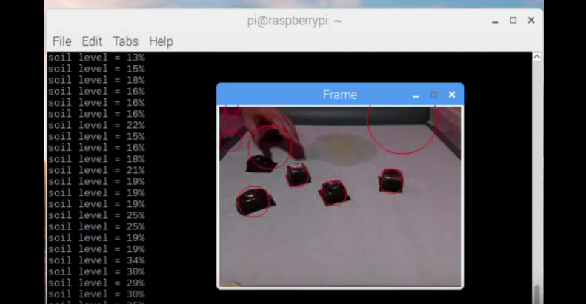

Video: <https://drive.google.com/file/d/1l1nEwbiLDIssO0hpcZLkULeMBshwpU8h/view?usp=sharing>

## Uncompleted Milestones

**Milestone 7 - Reiterate**

**Definition:** After mounting the devices on the Brilliant Pad, make adjustments as needed

**Deliverable:** CAD models with adjustments and pictures of the Pi Camera and Raspberry Pi mounted

**Expected Date of Completion: 2/18**

**Milestone 7a (Revision): Record accuracy of soiled level with different angles and height of the camera**

**Definition:** Test the accuracy of the waste detection at different angles and heights of the camera to see where the optimal location would be.

**Assigned To:** Richard

**Deliverable:** Charts and data tables

**Expected Date of Completion: 2/19**

**Milestone 7b (Revision) : Make camera detection more robust and accurate**

**Definition:** Improve the camera detection system, using a better algorithm or a different program and see which is better

**Assigned To:** Kevin, Richard

**Deliverables:** Charts and Tables if there are different programs used, or graph to show how much more accurate algorithm changes made

**Expected Date of Completion: 2/25**

**Milestone 7c (Revision): Make notes for possible mount redesign**

**Definition:** improve the mount based on comments from Brilliant Pad company

**Assigned To:** Derek

**Deliverable:** CAD for new design, new mount, and reasons for redesign

**Expected Date of Completion: 2/20**

**Reason for change:** We want to reiterate based on the customer, therefore we intend to provide the customer with more information to help us iterate in the right direction.

**(Removed) Milestone 8 - Analyzing pad  
Definition:** Determine if the pad should be advanced based on the level of dirtiness of the pad  
**Deliverable:** A notification that indicates the pad should be advanced (blink an LED)  
**Reason:** The level of dirtiness should be sent to the control subsystem which will make the final decision to advance the pad when needed. This will not be our focus, because kelton’s team (the other brilliant pad group) will be doing this.

**Milestone 8 (Revision)- Detecting presence of the Dog**

**Definition:** Determine whether or not a dog is present on the pad.

**Assigned To:** Kevin, Richard

**Deliverable:** Simulate a dog moving onto the pad. Indicate that a dog has been present recently (within the last X minutes). After a period of inactivity, indicate that the dog is no longer present.

**Reason for change:** To clear things up, we do not want the pad to advance when a dog is on the pad. We will only need to detect the presence of a dog. This will be used to signal whether it is OK or not OK to advance. Ideally, this information will be sent to the control subsystem which will make the final decision to advance the pad when when needed or to put it on hold.

**Expected Date of Completion:** 3/2

**Milestone 9 (Revision) - Ability to send signals over UART**

**Definition:** Test the capabilities or allow for the Raspberry Pi to send a signal, potentially to the Brilliant Pad

**Assigned To:** Derek, Kevin

**Deliverable:** A video demonstration of the Raspberry Pi/Arduino being able to communicate with the Brilliant Pad, through status messages sent through UART

**Reason for change:**  Being more realistic in our ability to communicate with the Brilliant Pad

**Expected Date of Completion:** 3/9

**Milestone 10 [Extra] - Communicate with Brilliant Pad**   
**Definition:** Contingent on Milestone 9 being possible, using UART to tell the Brilliant Pad to advance the pad  
**Assigned To:** Derek,Kevin, Richard

**Deliverable:** Video demonstration of the Raspberry Pi advancing the Brilliant Pad through UART  
**Expected Date of Completion:** 3/9

**Milestone 11 [Extra] - Integration of vision system with Brilliant Pad**

**Definition:** Telling the Brilliant Pad to advance the pad given input from our vision system  
**Assigned To:** Kevin, Richard

**Deliverable:** A video demonstration of the vision unit advancing the pad   
**Expected Date of Completion:** 3/9

**Milestone 12 - Ongoing documentation of process  
Definition:** After every milestone is completed, there should be documentation stating what was done, by who, and when it was completed. Documentation is especially important so that Brilliant Pad engineers can make use of our design.  
**Assigned To:** Kevin, Derek, Richard

**Deliverable:** Completed, accessible webpage  
**Expected Date of Completion:** 3/17

## Overall Milestone Responsibilities for Grading

### Derek:

B: 1a, 2a, 2b, 3, 4, 5, 12

A: 1a, 2a, 2b, 3, 4, 5, 7c, 9, 10, 12

### Kevin:

B: 1a, 1b, 1c, 2b, 4, 5, 6a, 6b, 6c, 12

A: 1a, 1b, 1c, 2b, 4, 5, 6a, 6b, 6c, 7b, 8, 9, 12

### Richard:

B: 1a, 2b, 4, 5, 6a, 6b, 6c, 12

A: 1a, 2b, 4, 5, 6a, 6b, 6c, 7a, 7b, 12